Who wants to be a millionaire?

The game introduces several questions, allowing players to earn money for each question answered correctly in a row. Players also have the possibility to choose from the three options [Figure 1.A] available to them : 1. Call a friend; 2. Ask the public; 3 Call a friend, in the scenario that they got stuck on any question. This educates the player on several topics and allows them to learn new information and also test their knowledge with 15 questions for the top prize of 1.000.000$.

Link to access the game webpage: “ <https://wwbm.com/> ”

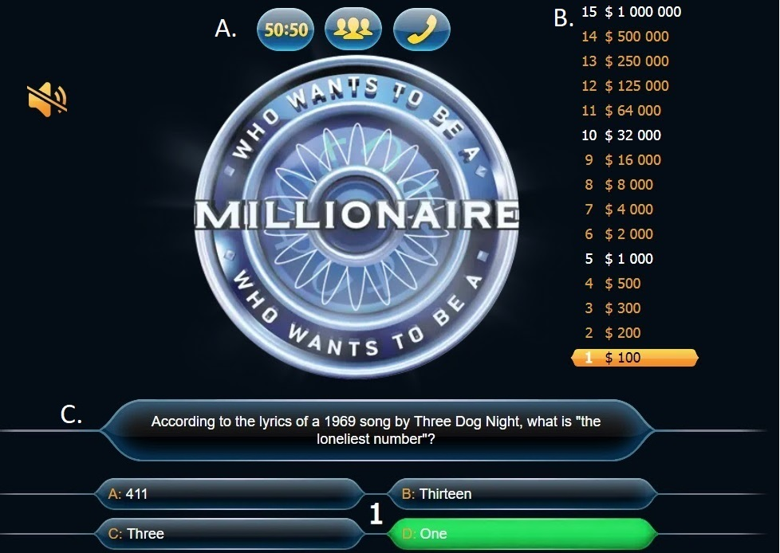

Figure 1: Who wants to be a millionaire. Image is showing the game interface with possible option for the player[A], the score [B] and the question that play has to answer [C].

Link to access the survey: “ https://docs.google.com/forms/d/e/1FAIpQLSeJn2QlKhFewhHEsVhuWdNKwec2RbWPtCyGeZ1ZfV26vlEb6Q/viewform ”

The reason for creating a 10 question survey was to collect data from users in order to discover the certain aspects of the game, such as finding out the age range of people playing the game, the reason they like it and what could be improved.

The survey included questions regarding the experience of players in playing computer games so as to be able to differentiate between the novices and the more experienced players; how many rounds were played to average out the results of the survey; the age and how difficult was the game for each individual.

The survey was completed by 7 people and some of the data that the survey provided was that more than 80% of the people surveyed played the game for 2 times or more (Figure 2) and it also was found out how difficult these players found the game to be (Figure 3).

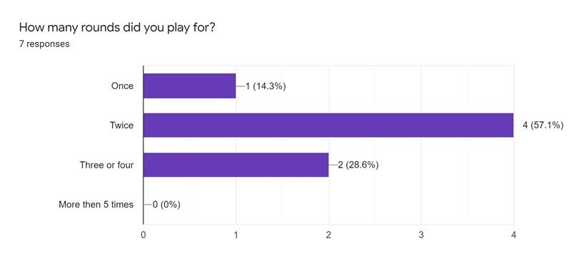

Figure 2. Report on rounds played – showing how many times the game have been played.

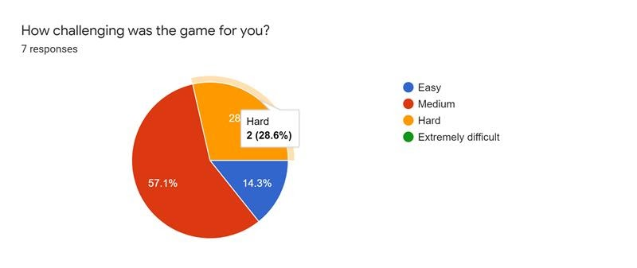

Figure 3. Difficulty level. Players expressing the difficulty they experienced when playing the game.

The survey itself was not perfect and following are some of the changes that could be made to the questionnaire:

* Refine the questions to provide more accuracy.
* Ask what topics the player found to be challenging.
* Ask whether they would play the game again or not
* The level that each player reached in the game.
* Allow users to rate the game on a number basis.

Creating the survey has been a challenging task since the questions had to reflect on and help the developers in finding out accurate information regarding the gameplay experience, information which would help developers to understand the accurate needs of those that took part of the survey. The reason for doing is based on the fact that the results could be used to improve certain aspects of the game.

This survey offered great information while analysing the data and following certain patterns it has been recognized that the game is balanced and that people answered on an average response to most of the questions in the survey.

The team that created the survey was made up of myself - Stefan-Alexandru Zarnescu, Conor Hadley and Alyssa Lamb.